
Name: Abdul Samad
Program: BSSE Group A
Semester: 5th
Date: October 1, 2026
*-----------------------------------------------*

Lab Task 4
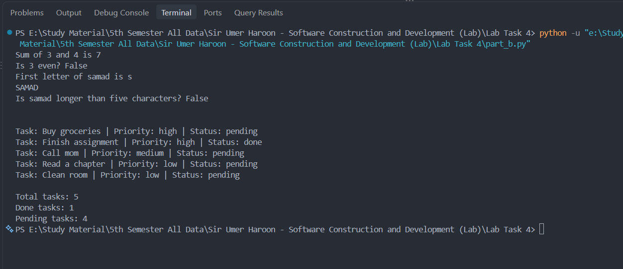
*-----------------------------------------------*

The End

